1. **Giewont peak**

**prominent, massif, resembles,**

Giewont mountain belongs to Western Tatra mountains. It actually consists of 3 peaks, the highest of which reaches 1895 metres.

It is the most characteristic mountain ………………………in Polish Tatras. Its peculiar shape ……………………………… a lying person and Giewont is also called *The Sleeping Knight*.

Giewont is also known for the 15-metre high steel cross, which makes it a popular destination among pilgrims. What is worth to mention here is that the cross makes Giewont even more dangerous during thunderstorms - the cross is a magnet for lightning and the mountain is the most …………………………… peak in the area.

1. **Morskie Oko**

picturesque, merges, meadows,

During one of our trips to Tatra mountains we did really good hiking – we walked about 30 kilometres! It was a challenging experience, but totally worth it - a fantastic landscape of [Tatra National Park](https://overhere.eu/tatra-mountains-number-one-must-see-in-poland/) rewards every effort.

We hiked to [Morskie Oko lake](https://overhere.eu/blog/most-beautiful-natural-wonders-poland/)but chose different trail than the majority of tourists. The red trail from Palenica Białczańska car park (Morskie Oko parking) is one of the most popular Tatra National Park trails. So, we decided to hike another trail.

This is definitely **not the fastest way to get to Morskie Oko**, but the advantage of this hike is very little tourists on the trail.

Then we follow the red trail. The path leads through forests and………………………….. On our way we pass **Rówień Waksmundzka** (1405 metres) -…………………………. mountain clearing, perfect to have a picnic or just lie on the blanket and stare into the sky.

After about 1 hour we get to **Wodogrzmoty Mickiewicza waterfall**. Here the trail ………………………………. with the popular road leading to Morskie Oko lake – the biggest and the most beautiful Tatra lake located on 1395 metres.

This is my least favorite trail in Tatra National Park.

**carriages, diversify, shortcuts,**

Morskie Oko is an amazing place, but it tends to get crowded - there are a few trails leading to the lake and it is easily accessible to all tourists (also those who do not like hiking).

Since Morskie Oko lake is so famous, there are always crowds of people and ……………………………. pulled by exhausted horses. I truly dislike this asphalt road and wonder why we chose to go there - it is not very comfortable for me to hike on 'artificial' paths. I am all for dirt trails.

Besides, there have been cases when a poor horse died while pulling the carriage because of heat and effort.

So, here is what I think: **if a person has legs and can walk, but does not like hiking, there are plenty of beaches for him/her to lie on**.

Fortunately, on the way to Morskie Oko there are steep forest …………………………….which make the hike a bit shorter. They are less crowded and more demanding - perfect to……………………………. the hike.

OK, let's get back to our hike.

When we get to Morskie Oko lake we are already rather tired as our hike already lasts over 5 hours. We need to keep in mind there might be no table available in [Morskie Oko mountain hut](https://overhere.eu/blog/mountain-huts-in-tatra-national-park/), so we can have a quick snack on a rock close to the lake and go back hiking the same trail.

1. **Five Lakes Valley & Zawrat Pass**

**enjoyable, commonly, scenic,**

Five Lakes Valley is considered to be the most ……………………….. valley in Tatra mountains. In the summertime, it is also an easy and ……………………………………..hike suitable for families with children. For me, it is one of the best hikes in Poland.

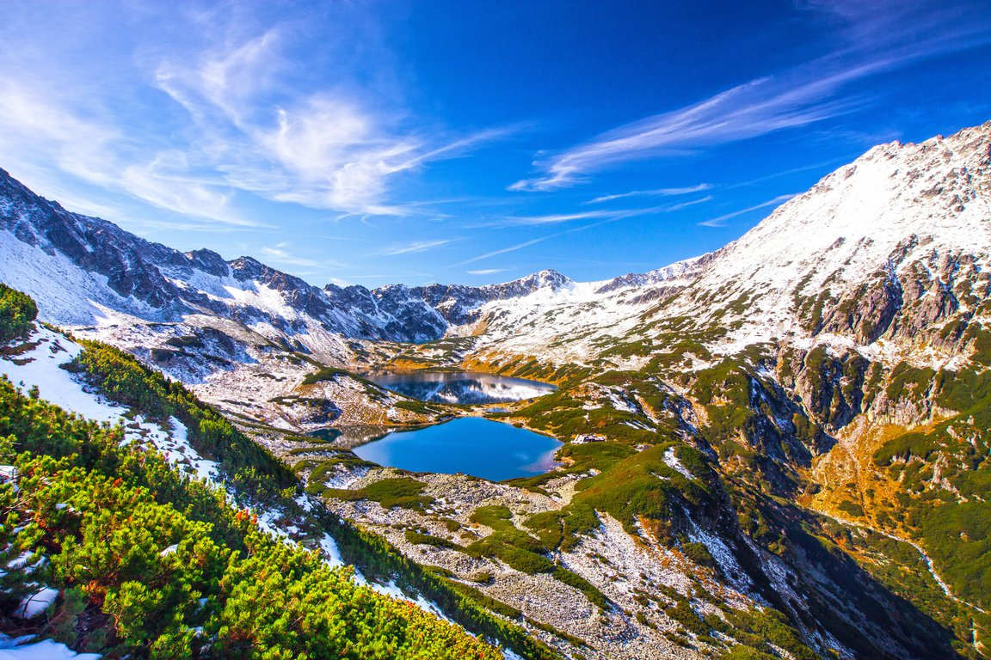

*The Five Lakes Valley © elfotonet / Adobe Stock*

We leave the car at the parking lot in Palenica Białczańska (984 metres). It is ………………………………………known as Morskie Oko parking. It is a very popular car park, so it is best to arrive early in the morning.

1. **Nosal mountain**

**trail, hikers, proximity,**

Nice and short, one of the easiest Tatra National Park trails - Nosal peak reaches only 1206 metres.

Nevertheless, it is an interesting ………………………… - it leads to a surprisingly high mount taking into consideration Zakopane ………………………..

It is perfect for families with children or tired ……………………….., who still want to enjoy the amazing nature of Tatra mountains, but are too tired for longer hikes.

1. **Czerwone Wierchy (Red Peaks)**

**exposure, steep, rewarding,**

My personal favourite and yet another one of the best hikes in Poland. It consists of 4 peaks, all of which exceed 2000 metres:

* Ciemniak (2096m)
* Krzesanica (2122m)
* Malolaczniak (2096m)
* Kopa Kondracka (2005m)

Red Peaks trail is not technically difficult. There are no ……………………………. points or chains. At some points the trail gets ………………………….., but the effort is rewarded with the spectacular landscape of Western and High Tatra mountains.

I hiked Red Peaks solo at the end of September 2018. I was expecting colorful autumn but had to hike in deep snow. Still, I consider it **the most ……………………….. mountain trail I have ever hiked**

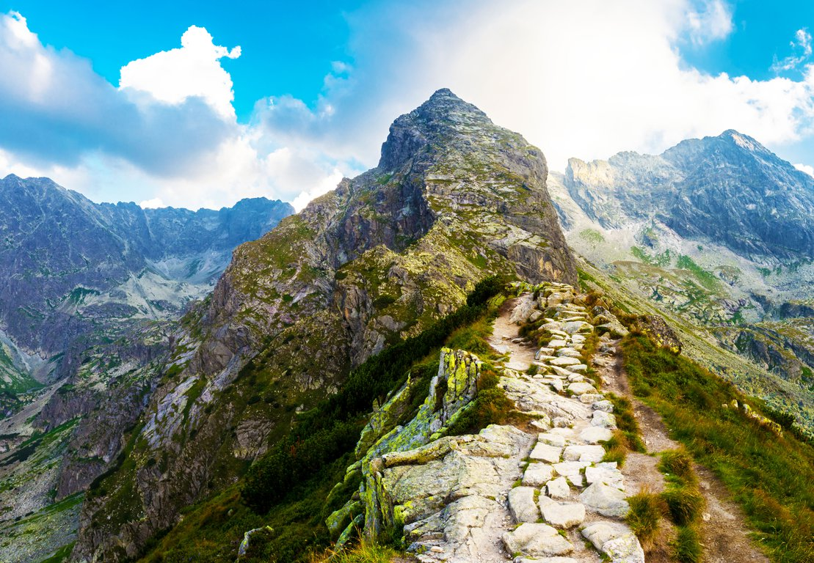

**unforgettable, resembles, panorama,**

This mountain belongs to **High Tatra range** and is considered to be one of the most beautiful mountains in Tatra National Park. Its characteristic pointed shape …………………………. Matterhorn.

I think it is one of the best hiking trails in High Tatras 💛.

However, this trail is suitable for a bit more experienced hikers, which I will explain below.

Koscielec peak reaches 2155 metres and the ……………………………………. from the top will make your hiking in Tatra mountains a truly memorable experience.